College of Arts and Sciences

Office of the Associate
and Assistant Deans

114 University Hall
230 North Oval Mall
Columbus, OH 43210

614-292-1667 Phone
asc.osu.edu

September 3, 2024

W. Randy Smith, Vice Provost
Council on Academic Affairs
Bricker Hall
CAMPUS

Dear Randy:

I am pleased to endorse the proposal by the Department of Evolution, Ecology and Organismal Biology to create a certificate in Research Methods in Biological Sciences, effective Spring 2025. The Department of Evolution, Ecology and Organismal Biology will be solely responsible for overseeing the certificate. The certificate (Types 1b) is focused on current OSU students.

The proposed curriculum is well designed and readily navigable, and addresses important issues related to research methods for students of the biological sciences. The certificate should be of interest to students across the life sciences in Arts and Sciences, and for undergraduate students in the health science colleges as well. The certificate does not duplicate any other currently offered at Ohio State; it complements existing minors in the department. It has the full support of the College of Arts and Sciences.

Sincerely,

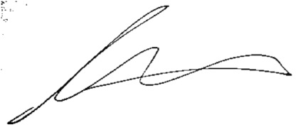

Andrew W. Martin
Associated Dean for Undergraduate Education
Professor, Department of Sociology

